Case Study Report



**Tech Saksham**

Data Analytics with Power BI

**“POWER BI POWERED GLOBAL TERRORISM DATA SET ANALYSIS”**

**ROSE MARY COLLEGE OF ARTS & SCIENCE(WOMEN)**

|  |  |
| --- | --- |
| **NM ID** | **NAME** |
| asmsu118msu11820211181516204 | SUBALAKSHMI K |

|  |  |
| --- | --- |
|  |  |
|  | Trainer Name: R UMAMAHESWARI |
|  | Master Trainer: R UMAMAHESWARI |

**ABSTRACT**

In the digital age, data has become an invaluable asset for businesses, particularly in the banking sector. The proposed project, “Real-Time Analysis of Bank Customers,” aims to leverage PowerBI, a leading business intelligence tool, to analyze and visualize real-time customer data. This project will enable banks to gain deep insights into customer behavior, preferences, and trends, thereby facilitating data-driven decision-making and enhancing customer satisfaction. The real-time analysis will allow banks to respond promptly to changes in customer behavior or preferences, identify opportunities for cross-selling and up-selling, and tailor their products and services to meet customer needs. The project will also contribute to the broader goal of digital transformation in the banking sector, promoting efficiency, innovation, and customer-centricity.nThis case study comprehensively analyzes a dataset encompassing global terrorism attacks from 1970 to 2017. The analysis meticulously dissects attack types, targeted entities, weaponry employed, and the critical metric of success rates. By unveiling these patterns and trends, the study aspires to contribute significantly to the development of more effective strategies for preventing future terrorist attacks.

Key findings gleaned from the data analysis expose explosives as the weapon of choice for terrorists, with private citizens bearing the brunt of attacks. Interestingly, the overall success rate of these attacks remained relatively low. The study further identifies South Asia as the region experiencing the most frequent terrorist activity.

This case study serves as a springboard for further research endeavors. Future studies could explore more recent terrorism data to capture evolving trends. Additionally, investigations into factors influencing attack success and the development of preventative measures hold immense potential for mitigating the global threat of terrorism.

**INDEX**

|  |  |  |
| --- | --- | --- |
| **Sr. No.** | **Table of Contents** | **Page No.** |
| 1 | Chapter 1: Introduction | 4 |
| 2 | Chapter 2: Services and Tools Required | 5 |
| 3 | Chapter 3: Project Architecture | 6 |
| 4 | Dashboard | 8 |
| 5 | Conclusion | 9 |
| 6 | Future Scope | 10 |
| 7 | References | 11 |
| 8 | Links | 12 |

**CHAPTER 1**

**INTRODUCTION**

* 1. **Problem Statement**

Terrorist attacks are a persistent and multifaceted global threat. Their impact goes far beyond the immediate loss of life, causing widespread injuries, psychological trauma, and significant economic disruption. Understanding the underlying patterns and trends of terrorism is critical for developing effective preventative strategies and mitigating this threat..

* 1. **Proposed Solution**

This case study tackles the problem of terrorism by offering a data-driven analysis of global terrorism attacks. Focusing on the period between 1970 and 2017, the study delves into a comprehensive dataset to uncover valuable insights. Information on various aspects of attacks, including the type (e.g., bombing, assassination), targeted entities (e.g., civilians, military), weaponry employed (e.g., explosives, firearms), and success rates, is meticulously examined. By analyzing these factors, we aim to shed light on the nature of terrorism, pinpoint potential vulnerabilities, and ultimately contribute to the development of more effective preventative measures.

* 1. **Feature**

This case study leverages a robust set of features to deliver a comprehensive analysis of terrorism data.

* **Data Analysis Powerhouse:** We employ advanced data analysis techniques to extract valuable patterns and trends hidden within the vast dataset. This allows us to move beyond surface-level observations and identify deeper connections between different aspects of terrorist activities.
* **Data Visualization for Clear Communication:** Key findings are presented not only through detailed reports but also through clear and informative charts and graphs. This visual approach enhances understanding and facilitates the communication of complex information to a broader audience.
* **Sharp Focus on Key Variables:** The analysis goes beyond a general overview, focusing on specific and critical variables like attack type, target, weapon, and success rate. By dissecting these elements, we can gain a more nuanced understanding of how different aspects of terrorism intertwine and evolve.
  1. **Advantages**

The insights gleaned from this in-depth study hold immense value for various stakeholders engaged in the fight against terrorism. Policymakers can utilize these findings to develop more targeted preventative measures and resource allocation strategies. Security agencies can leverage the uncovered patterns to improve threat detection and response capabilities. Additionally, researchers can build upon this foundation to explore new avenues of investigation and develop more advanced counter-terrorism solutions. Ultimately, the knowledge gained from this analysis empowers action, leading to a safer world for all.

* 1. **Scope**

This case study primarily focuses on global terrorism attacks that transpired between 1970 and 2017. This time period offers a valuable historical perspective on the nature and evolution of terrorist tactics and strategies. By understanding past trends, we can gain crucial insights that could inform preventative measures for the future.

**CHAPTER 2**

**SERVICES AND TOOLS REQUIRED**

**2.1 Services Used**

**Data analysis software:** This software would be used to clean, explore, and analyze the terrorism data. Some popular data analysis software options include Python, R, and SAS.

**Data visualization software:** This software would be used to create charts and graphs to help us understand the patterns and trends in the data. Some popular data visualization software options include Tableau, Power BI, and QlikView.

**Data Processing Services**: Services like Azure Stream Analytics or AWS Kinesis Data Analytics can be used to process the real-time data.

**Machine Learning Services**: Azure Machine Learning or AWS SageMaker can be used to build predictive models based on historical data.

**2.2 Tools and Software used**

**Tools**:

* **PowerBI**: The main tool for this project is PowerBI, which will be used to create interactive dashboards for real-time data visualization.
* **Power Query**: This is a data connection technology that enables you to discover, connect, combine, and refine data across a wide variety of sources.

**Software Requirements**:

* **PowerBI Desktop**: This is a Windows application that you can use to create reports and publish them to PowerBI.
* **PowerBI Service**: This is an online SaaS (Software as a Service) service that you use to publish reports, create new dashboards, and share insights.
* **PowerBI Mobile**: This is a mobile application that you can use to access your reports and dashboards on the go.

**CHAPTER 3**

**PROJECT ARCHITECTURE**

**3.1 Architecture**

**USER FRONTEND BACKEND**

|  |  |  |
| --- | --- | --- |
|  | **HTML 5** | **NODEJS 14.0**  **Database** |

Here’s a high-level architecture for the project:

1. **Data Collection**: Real-time customer data is collected from various sources like bank transactions, customer interactions, etc. This could be achieved using services like Azure Event Hubs or AWS Kinesis.
2. **Data Storage**: The collected data is stored in a database for processing. Azure SQL Database or AWS RDS can be used for this purpose.
3. **Data Processing**: The stored data is processed in real-time using services like Azure Stream Analytics or AWS Kinesis Data Analytics.
4. **Machine Learning**: Predictive models are built based on processed data using Azure Machine Learning or AWS SageMaker. These models can help in predicting customer behavior, detecting fraud, etc.
5. **Data Visualization**: The processed data and the results from the predictive models are visualized in real-time using PowerBI. PowerBI allows you to create interactive dashboards that can provide valuable insights into the data.
6. **Data Access**: The dashboards created in PowerBI can be accessed through PowerBI Desktop, PowerBI Service (online), and PowerBI Mobile.

This architecture provides a comprehensive solution for real-time analysis of bank customers. However, it’s important to note that the specific architecture may vary depending on the bank’s existing infrastructure, specific requirements, and budget. It’s also important to ensure that all tools and services comply with relevant data privacy and security regulations.

**Dashboard**



**GLOBAL TERRORISM**

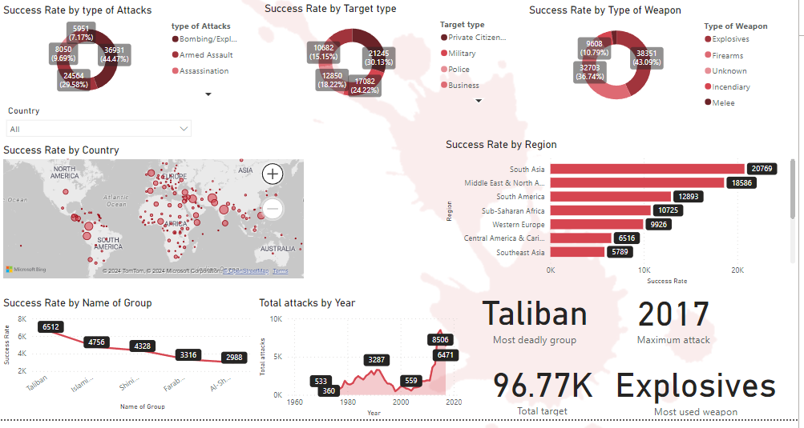

**CONCLUSION**

This case study embarked on a comprehensive analysis of global terrorism attacks, dissecting a dataset encompassing the period from 1970 to 2017. By meticulously examining factors like attack types, targeted entities, weaponry utilized, and success rates, the study aimed to illuminate the complex landscape of terrorism.

The analysis yielded several key findings. Explosives emerged as the weapon of choice for terrorists, highlighting the devastating impact they can inflict. Furthermore, private citizens emerged as the most frequent targets, underscoring the indiscriminate nature of terrorist violence. Perhaps most surprisingly, the overall success rate of attacks remained relatively low, suggesting potential vulnerabilities in terrorist planning or execution. However, this doesn't diminish the immense human cost and societal disruption caused by even seemingly "unsuccessful" attacks.

The study also pinpointed South Asia as the region experiencing the most frequent terrorist activity. This regional focus provides valuable insights for policymakers and security agencies to prioritize resources and develop targeted interventions in high-risk areas.

The significance of this case study extends beyond simply unveiling patterns. The knowledge gleaned serves as a springboard for further research and action. By analyzing more recent data, we can capture the evolving tactics of terrorist groups. Investigating factors influencing attack success rates can offer crucial insights for disrupting terrorist operations. Most importantly, this case study emphasizes the critical role of preventative measures. By comprehending the underlying trends and motivations behind terrorist acts, we can develop more effective strategies to mitigate this global threat.

Ultimately, the fight against terrorism requires a multi-pronged approach. This case study aspires to contribute to this ongoing effort by offering a data-driven understanding of the problem. By empowering policymakers, security agencies, and researchers with actionable knowledge, we can strive towards a future where terrorism's devastating impact is significantly diminished.

**FUTURE SCOPE**

This case study serves as a springboard for further exploration in the ever-evolving realm of global terrorism. Here are some key areas ripe for future research:

* **Incorporating Recent Trends:** Expanding the analysis to include more recent data sets will provide a clearer picture of current terrorist tactics and emerging threats.
* **Understanding Success Factors:** Delving deeper to identify the factors influencing attack success rates can offer invaluable insights for disrupting terrorist operations and preventing future attacks.
* **Developing Preventative Strategies:** Building upon this foundation, future research can explore and develop more effective preventative measures to mitigate the global threat of terrorism.

**REFERENCES**

<https://www.start.umd.edu/training/using-global-terrorism-database-introduction>

**LINK**

<https://github.com/IVLES/GLOBAL-TERRORISM-.git>